Prog # 1

**CIS 310 (Yoon)**

**Winter, 2021**

**Upload it by 2/14/2021 (Sun)**

**Read Chapter 3 of the Irvine’s book. Download the file “Getting started with MASM and Visual Studio ” from** [**www.asmirvine.com**](http://www.asmirvine.com)**. Make sure that your VS is based on C++. Otherwise MASM will not work.**

**This programming assignment is essentially Programming Exercise # 1 in Section 3.10 on p. 94.**

**Define variables A,B,C1,D as double words (DWORD) and initialize them to 30, 20,10,5, respectively. Copy them to registers EAX, EBX, ECX, and EDX, respectively (see Fig. 2.4). Then compute**

**A = (A+B) – (C1+D)**

1. **Build/run the program without debugging.**
2. **Run the program in the debugging mode and add the register window to a debugging session (see Fig. 3.5).**
3. **Generate the listing file like the one in Fig. 3.8.**

**Upload the screenshots from 1, 2 and 3.**

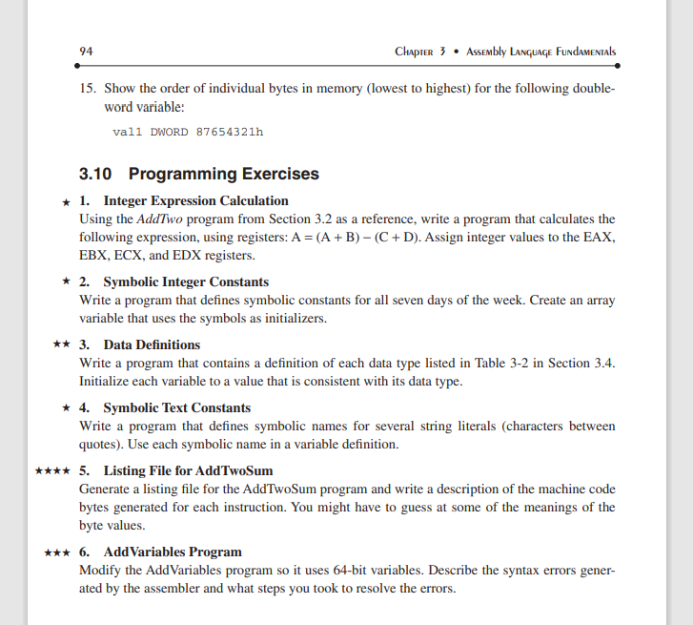

(see page 98 in pdf version for AddTwo program in section 3.2)

